Batch: Roll No.:
Experiment / assignment / tutorial No._______
Grade: AA / AB / BB / BC / CC / CD /DD

Signature of the Staff In-charge with date

PCB Workshop (2023-24)
Design and Manufacturing of Printed circuit Board (PCB).

Title: 1.Design the PCB artwork for the circuit with the help of software.
2. Prepare the PCB by Photo Chemical Process.

Theory:
What is PCB?
A printed circuit board, or PCB, is used to mechanically support and electrically connect electronic components using conductive pathways, or traces, etched from copper sheets laminated onto a non-conductive substrate. It is also referred to as printed wiring board (PWB) or etched wiring board. A PCB populated with electronic components is a printed circuit assembly (PCA), also known as a printed circuit board assembly (PCBA).PCBs are rugged, inexpensive, and can be highly reliable. They require much more layout effort and higher initial cost than either wire-wrapped or point-to-point constructed circuits, but are much cheaper and faster for high-volume production.
Prior to manufacuring PCB, one needs tp prepare layout for the circuit. In the layout preparation we need to consider the placement of various devices and components used in the circuit, the size of the component. The layout prepartion is done using varoius EDA (Electronics Design Automation) softwares such as ORCAD, EGLE, EXPRESS PCB, DIPTRACE etc. following tips and guidelines should be taken into account in layout preparations.

Tips on PCB Designing

At the start of design process, designer must follow these details:
- Accurate actual sizes of the components being used.
- Electrical connections between components.
- Component mounting data.
- PCB area.
- Conductor width and spacing.

On the bass of above data, a designer must follow the following points:
- All components must be represented.
- There can be no crossovers in tracks. A crossover will result in shorting of tracks .
- Always keep point –to –point conductor runs as straight and as short as possible. When unable to use straight lines, use diagonal lines. Combination of straight lines, diagonal lines and 90 –degree bends should be used for track layout.
- Avoid looped runs.
- Polarity marks should be drawn for power terminals, diodes, electrolytic capacitors and any such polarized components.
- Place all resistors, capacitors, diodes etc. parallel to each other and parallel to PCB.
- Try to group components together on the basis of functional block, component type, and similarity in dissipation, size or polarity.
- Put high wattage resistors and power semiconductors away from the centre of the PCB. Keeping such components near edges facilitates putting up of heat sinks.
- Keep a margin of at least ¼” on all sides to allow a space between board edges and actual components. This space can be used only for mounting of connectors, or PCB mounting screws.
- Keep number of jumpers minimum.
- Mount the components as close to each other as possible, leaving only minimum space required between to service the components. Typical distance between transistors and ICs will be around 1/8” or ¼”.
- For currents up to 1A, use track size of 1/16” or 1.5mm approx. For higher currents increase the track width approximately.
- Spacing between tracks is a function of the voltage. Typical values are –
0 – 150 V 1/32”
150 – 300V 1/16”
301 – 500V 1/8”
- Make use of power and ground bus concepts to simplify the track layout.
- Think of symmetry while arranging components. Try to spread the component weight evenly across PCB.
- Try to place large and small components alternately.

GUDELINES FOR PREPARING COMPONENT LAYOUT.

- Ensure that you have all the required components with you.
- Note down accurate measurements of each component.
- Show PCB mounting holes at the corners at 70mmX70mm.
- Distribute the components evenly over the area. You need not mark this area. Only make sure that this entire area is used.
- Ensure that heavier components are towards the centre.
- Keep components with heat sinks, power resistors, ICs near centre.
- All axial lead components should be placed either horizontally or vertically.(i.e. parallel to PCB edges)
- Pads for external wire connection, or the components where external wire is terminated directly, should be towards the edges of PCB.
- For axial lead component like resistor, distance between the mounting holes will be (body length in mm +6 mm) minimum.
- While deciding the component position, think of connected components and place the components in such a way that path length between two connected components is minimum.
- You need not accommodate transformer, power supply& signal source on the PCB. Provide pads to terminate external wire or you can solder the external wire directly onto the appropriate component lead. In such case take care to locate that component towards the edges of PCB.
- Show at least the mounting holes for every component. Showing component out line (Shape & size) is preferred but not must.
You will proceed to make track layout only after your component layout is corrected & approved.

I. Preparation of layout using DIPTRACE
- Open the DIPTRACE Software.
START→ Programs→DipTrace→PCB lyout.
Following window will be seen on the monitor.
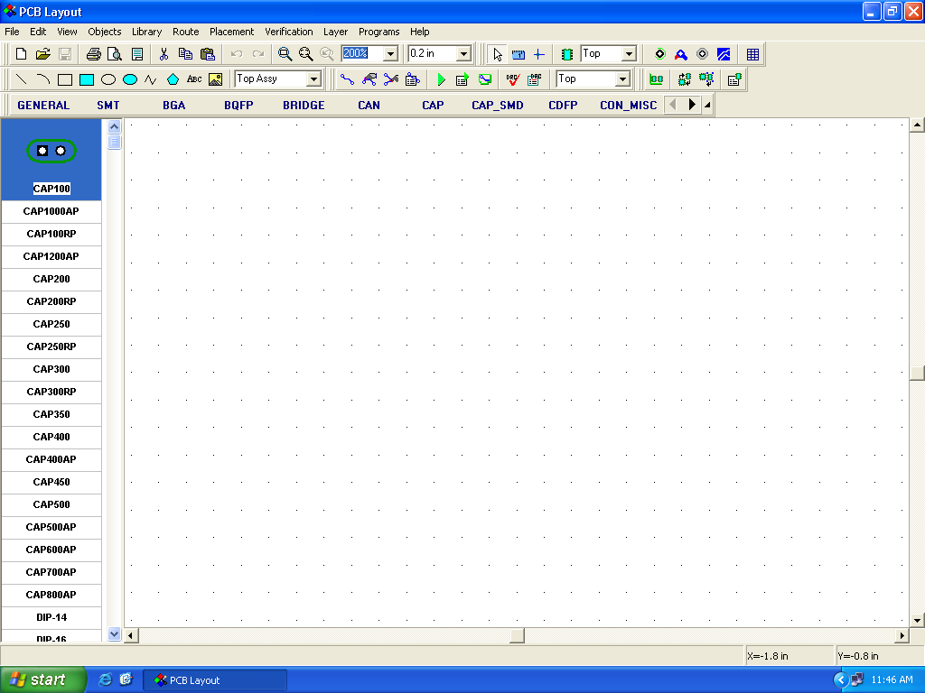

- Standard components sizes such as resistors, capacitors, transistors and ICs with various package types, are available in the library of the DipTrace. The list of the components is displyed alphabetically on the left of the Diptrace layout window. Select, Drag and drop the required component as shown below. As the components are placed on the Top layer of the PCB, while placing the components, select the layer settings shown with arrows. The properties of the components such as rotation can be changed by selecting the component and right clicking.
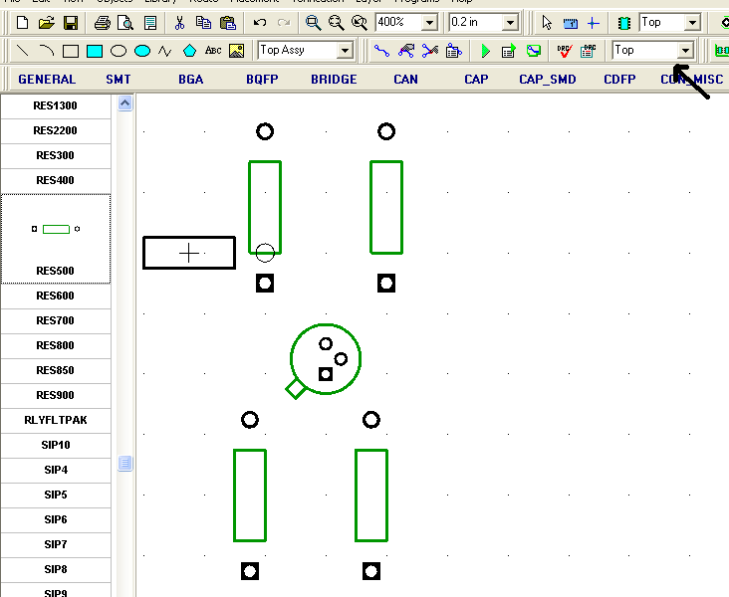

- After the placement of the components. Select the bottom layer and make all the connections using the traces available in Menu bar shown with arrows in the following figure. Following figure is a layout for the Transitorised common emitter Amplifier. The Text is used to name the components or its value on the top layer. The width of the traces etc can be changed by selecting the trace and right click.
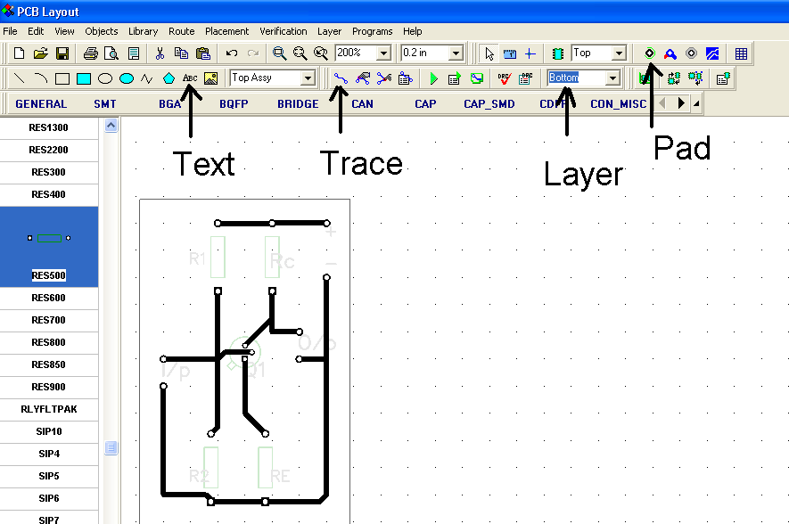

- After the connections are complete click “Run Autorouter” button in the toolbar to form a board of your prepared layout.

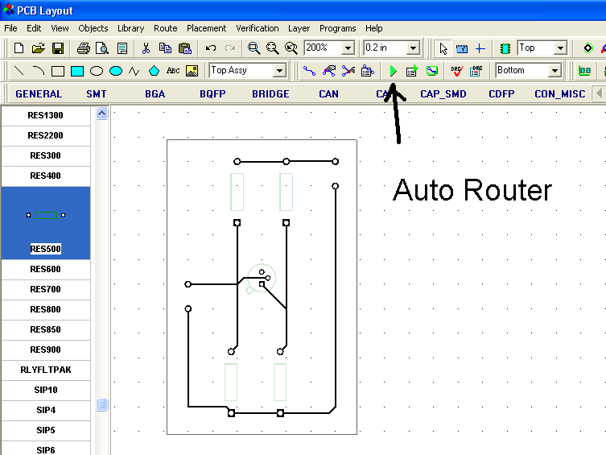

- The photo chemical process of PCB manufacturing needs the negative of the layout. The Dip trace software can give the printout of the layout as it is (Positive) or negative of any layer. But we need the negative of the bottom layer. The following steps should be followed to get the print out.
In Dip Trace window click File→ Preview. The preview window will be opened only if the printer is connected to your PC. Use the laser printer only to take the printout of your layout negative. Do the settings in the preview window as shown below. The printout should be mirror image of the negative. Get the printout on the A₄ size Butter Paper. Depending on the darkness of the black Area which is actually the unwanted copper, the multiple printouts can be taken and can be overlapped.

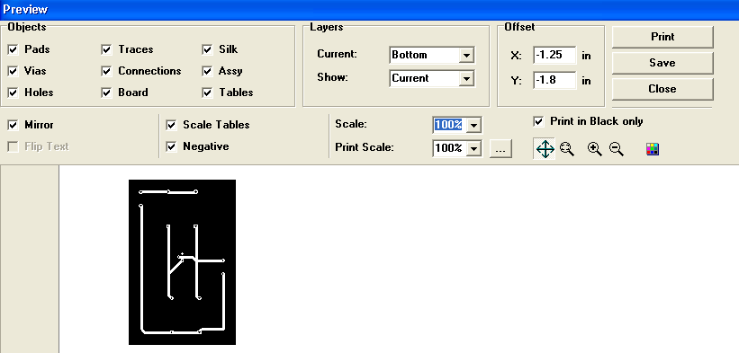

II FABRICATION OF PRINTED CIRCUIT BOARD

- Introduction –
The method of making your own Printed Circuit Board is described in the following guideline..
Even if you have never fabricated a PCB before, with a little practice you will be able to produce PCB of professional grade for prototyping or even a finished product.
The manual artwork method of PCB design is the method used by most manufacturers of PCBs. With this method, extremely accurate, high density printed circuit boards can be constructed, since the artwork can be produce 1, 2 or 4 times the size of the final PCB. This method consist of applying tapes, donuts pad, multi pad configurations (for integrated circuit) letters, numbers and words, to a sheet of Mylar film.
If the artwork is done by computer aided design, please ensure that the output is on an accurate good quality laser, and not a dot matrix printer, as pinholes will lead to defects in the final PCB.
There are commercial photo-sensitive resist, which are very practical for producing circuits on PCB. Placing the circuit design on a negative helps actual production of circuits. Exposing the negative while in contact with coated (photo sensitive) circuit board is done first. Then developing and other processes are required to form the circuit boards.
There are durable photosensitive resist of organic. Solvent solutions which are Ultra Violet Light sensitive. These can be processed and used easily in laboratory.
The resist may be applied in double coats in a dip coating machine. With a dip coater the resist is coated very accurately on the required PCB laminate and dried it is then exposed to contact with negative with the design to an actinic light source (U. V.). The non-exposed parts are dissolved by developing with the recommended developing solution.
This leaves the circuit resist on the required parts of the metal on the PCB. The non coated or unprotected metal may be etched in an etching solution such as ferric-chloride solution. After etching and washing the resist is removed with the required solvent and a very accurate circuit configuration is left on the circuit board.
While drilling the board be sure that drill bit is sharp. Best result for glass epoxy board material will be maintain with carbide tipped drill bit, but you can use an ordinary high speed steel (HSS) drill bit if that is all you have. For most component proper drill size is 1 mm. diameter and for integrated circuit .8mm is used. The specified drill sizes are not critical, but it is good if we don’t use too large drill since it makes it more difficult to get a proper solder connection.
- Process
In photo transfer processes cleanliness is very important. This applies to all steps you follow to achieve the desired results. Whether you are making metal labels or Professional grade PCBs, please ensure that your work tables, apparatus, tanks, trays are completely free from dirt and dust.

Cleaning the Laminate-
Before the metal surface (in case of the bare PCB Copper laminate) is coated with photo resist, clean the surface thoroughly, so as to make it completely free of physical & chemical contamination .It is advisable to clean the metal by solvents like trichloroethylene to remove traces of grease or oil. Contaminants such as cupric-oxide, dirt etc can be removed by applying abrasives like pumic powder. Traces of such cleaning powder should then be removed by washing the metal plates under running water and scrubbing it with a soft brush or pad. The surface should then be quickly and thoroughly dried with forced warmed air.
Coating the Laminate-
Photo resist can be applied precisely and economically by using a dipping process, done by a Photo resist Dip Coater.
Dip coating is the best method of photo resist coating . Ti is used when the number of
Laminates to be coated is high and generally both the side of the laminates are to be coated. Stainless steel tank is used for storing the photo resist coating material. You have to dip or immerse the laminate in the tank containing photo resist and withdraw it slowly (withdrawal at rate of 30 to 40 cm/minutes) .Therefore the motorized arrangement for this operation is required.
It is difficult to predict a particular coating thickness needed for specific application because the coating methods and the equipments used change from user to user. It is therefore best to determine the optimum coating thickness experimentally.
Thinner
Use of thinner is to be done very carefully. The use of thinner will depend upon the method of coating you are following.(Photo resist’s viscosity -12 secs FC4).The thinner
is used to dilute the photo resist , as it tends to get thick during non –use.
Pre-baking –
After coating the laminate, allow it to dry naturally for minimum 5 minutes. Tis helps to evaporate the solvents completely. If the coating is thick it is also desirable to bake the laminate in PCB curing machine with controlled temperature at 30º- 45º C for about 10 minutes.
All operation related to coating and pre-baking are to be carried out in safe (yellow) light

Exposure –
The coated laminate is normally exposed in contact with photographic negative or positive. Photo resist is sensitive to ultra violet radiations and therefore an Ultra-violet tubes based, UV exposure unit can be used for exposure.
The time of exposure depends on many factors e.g. the source of light, thickness of coating, distance between the source of light and printing down frame etc.
The time of exposure depends on many factors e.g. the source of light and printing down Frame etc.For double side PCBs it is desirable to use double sided sandwich glass for printing frame

Development-
The exposed plate should be placed into the solvent –based developer. This will remove unexposed areas of the photo resist and will show a colorless resist image which has plastic-like appearance. The total development time is between 60-90 seconds.
The developer gets exhausted after continuous use and it is necessary to keep a periodical check on it. The exhausted developer creates scum in the non-image areas, When such trouble occurs, developer should be replaced and the container of the old developer should be cleaned before pouring fresh developer in it.

Washing-
Immediately after development is over, wash it in running water on neutral PH. After washing and drying, dyeing is carried out to improve the visibility of the image and to find out any cracks or broken line and to facilitate the same for the purpose of retouching before etching.

Dying the image-
Immerse the dried plate in the dye developer bath. The surface of the board is covered with a dye-developer. The board is put under running water of neutral PH in order to wash off the dye stain from the unexposed area, which results into a clean dyed image of photo resist and dry.
A dyed image can show you pinholes in the image areas that may be due to unclean printed frame or dusty, negative or positive. Occasionally black spots appear in the resist areas. These may be due to foreign matters in the resist coating, which is a continuously used without filtration. It is better to repair these defects in the image area otherwise they may become the source of trouble in further process.

Etching-
This is an important and critical step in the chemical processing of the direct-etched
Boards. Although basically this operation aims at chemical, removal (etching) of unwanted copper portion (non-image area). The operation must bear in mind the important of the definition tolerance possible, under cutting and contamination of a board substrate due to enchants. Good results can be obtained by carefully studying the various aspects of the operation.

Ferric Chloride is one of the most widely used enchants for copper and copper alloys .
The main reason for its popularity is the low cost. Commercially it is available in lumps or ready to use solutions of different strengths.
Various methods are used while chemically removing the unwanted copper from the laminates.
- In the proto-Etch Etching machine, the laminates are put in a tank filled with enchant agitated by a pump & a heater .The heater helps the enchant to become warm and helps to each PCB’s faster. Fresh enchant is available to the surface areas while the dissolved metal from the surface is rinsed away simultaneously .A sensor is provided for maintaining temperature.
- IN the Oscillating spray etching machine, the technique of spraying the etchant with moving nozzles, has double side etching either in horizontal and vertical positioning to production is the greatest advantages of these machines but the cost of equipment is more.
Whatever the method you follow for etching the laminate, please do not forget to cleaned the etched boards after the etching is complete.

Resists Removal:
After the etching or plating job is complete it is desirable to remove the resist from the image area, photo resist stripper is used to remove the resist from PCB the cleaned surface should be washed with water and dried quickly.

Trouble Shooting:

Problem Causes
- Exposed coating has a spongy a) Inadequate exposure time
appearance or mat finish after b) Thick coating
development.
- Exposed coating peels off a) Inadequate exposure time
during development. b) Very thick coating
c) Laminate surface not sufficient clean
3. Exposed coating does not develop a) Pre-baking beyond 50°C for longer
time
4. Dyed- image does not look intense a) Thin coating.

Protective Coating (Tinning):
Roller tinning unit is used for solder coating of PCB to provide an effective protection against corrosion and ensuring along storage life and improve Soldering properties. After cleaning & fluxing, the PCB to be solder coated is passed between two rotating rollers the one at the bottom being the tinned roller which partially dips into a solder bath and the top silicon rubber covered idle roller. The hot solder on the timed roller transfer on to the copper patterns of the PCB.

Drilling:
The drilling of PCB is done for making holes on the conductor pattern for inserting the component leads to the solder side of the PCB
Plated Through-Hole PCBs
Once your college already has a basic PCB making lab, without a plated- Thru-
Hole PCB facility (PTH is now a commonly used PCB in industrial and consumer electronics.) the lab will be incomplete. Once your staff/ college is familiar with single sided PCB making, it may be a good time to upgrade to include a PTH
Lab
The Micro – Plate Upgrade is a Prototype PTH PCB making module, ideally
Suited for educational and R & D institutions. It includes all the equipment
and start- up raw materials for fabrication of PTH PCB used in projects and even
Commercial electronics.
III. PCB Designing and Manufacturing guide lines

- Circuit Diagram
Use: PCB layout, artwork, troubleshooting, user’s manual and assembly.
Information:
- All symbols drawn from the standard symbol drawing. which are updated as and when required.
- Component nos. (R1, C1 etc.) as per final component layout or component assembly.
- Component values with complete specifications.
- All pins, used or unused.
- Description of connectors.
- All test points (numbered).
- All components including decoupling capacitors and jumpers.
- Any other information. E.g. Jumper meaning. Port addresses etc.
Refer: System specifications

- Writing Diagram
Use: Assembly, testing, Installation & troubleshooting.
Information:
- Wiring related to physical parts.
- Connector details as pin numbers and types.
- Colour codes as of all wires, if any.
- Wire sizes.
- Ferrule – identification number and signal name.
Refer: Wiring diagram including wire length etc.

- Component List
Use: R& D, testing, Formulation of parts list
Information:
- Component number (one item written on one line) as on the circuit diagram as well as component layout or assembly diagram.
- Complete description.
- Manufacturer’s item code/ Part no.
- Remarks for alternatives or special instructions.
Refer: Circuit diagram, wiring Diagram, Component layout, Parts list Bill of Material), Structure diagram

- Component Layout

Use: Assembly, Testing, Troubleshooting
Information:

- All Components Number in Sequence either horizontal or vertical.
- Back annotated to the circuit diagram.
- Mechanical fixing if any.
- PCB size and shape.
- All Components outlines as per actual dimensions.
- Components numbers as per standard circuit symbol.
- Silk screen (optional).

Refer: Circuit Diagram, Component layout (Bill of Material) and Drilling Details

- Parts List

Use: Purchase, Production Planning and inventory control
Information:

- Part No.
- Components Number.
- Full Description with make and options.
- Supplier Name.
- Quantity per sub-assembly or assembly, whichever preferable.
- Location in stores
- Remarks.

Refer: System Specifications

- Drilling Details

Use: PCB Manufacturing
Information:

- Drill size.
- After or before plated through holes (PTH) normally after PTH.
- Standardized color codes.
- Viewing side.
- Non-Plated through holes as mounting holes.
- PCB number.

- Artwork

Use: PCB Manufacturing
Information:

- PCB number, normal or mirror as per the side of PCB.
- Revision of artwork.
- Component side, solder side or layer no.
- Exact PCB dimensions in 1:1 scale.
- The side that is matched while taking films.

Refer: Circuit Diagram, Component Layout, Drilling Details

- Films

Use: PCB Manufacturing
Information:

- PCB number, normal or mirror as per the side of PCB.
- Revision of artwork.
- Component side, solder side or layer no.
- Exact PCB dimensions in 1:1 scale.
- The side that is matched while taking films.

Refer: Circuit Diagram, Component Layout, Drilling Details

- Block Diagram

Use: Explanation of complete system
Information:
Block diagram of complete system, explaining all functional aspects of the system and its blocks.

Refer: System specifications.

